Customer Database

Create a collection by name Customers with the following attributes.
Cust_id, Acc_Bal, Acc_Type?
use bankDB
db.createCollection("Customers")

Insert at least 5 values into the table?
db.Customers.insertMany([
{ Cust_id: 101, Acc_Bal: 1500, Acc_Type: "Z" },
{ Cust_id: 101, Acc_Bal: 1600, Acc_Type: "A" },
{ Cust_id: 102, Acc_Bal: 1700, Acc_Type: "B" },
{ Cust_id: 103, Acc_Bal: 1800, Acc_Type: "C" },
{ Cust_id: 103, Acc_Bal: 800, Acc_Type: "Z" }])

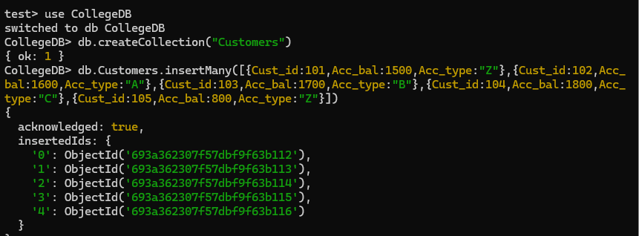

Write a query to display those records whose total account balance
is greater than 1200 of account type ‘Z’ for each customer_id.?
db.Customers.aggregate([
{ $match: { Acc_type: "Z" } },
{ $group: { _id: "$Cust_id", TotalBalance: { $sum: "$Acc_bal" }}},
{ $match: { TotalBalance: { $gt: 1200 } } }])

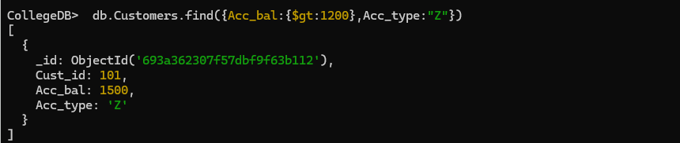

Determine Minimum and Maximum account balance for each customer_id.?

db.Customers.aggregate([{$group: { _id: "$Cust_id", MinBalance: { $min: "$Acc_Bal" },MaxBalance: { $max: "$Acc_Bal" }}}])

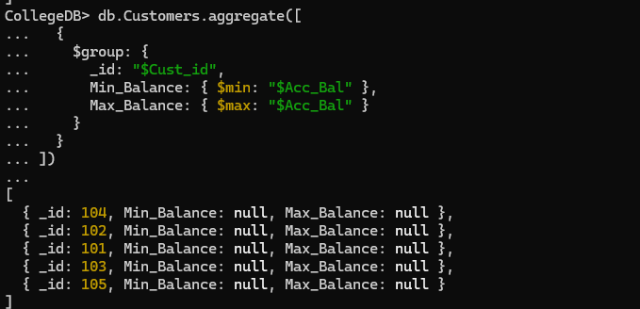

Drop the table.

db.Customers.drop()



